

**At**

**Chapel Street Nursery School**

**We take the SAFEGUARDING of children very seriously**

If you have any worries or concerns about the safety of any children from this Nursery School, want some support or need to ask a question, please look out for any of these people who will be happy to help you. If you can’t find them ask a staff member, who will find one of them for you.

**Chapel Street Nursery School Safeguarding Team**

****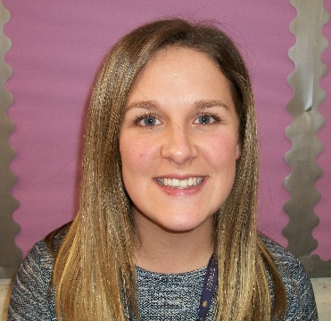

Sarah Gilbert

Headteacher

Liz Jenkins

Deputy Headteacher

Sarah Cain

Designated Safeguarding lead

**Conversations about Safeguarding can be private and confidential, unless we hear something that needs to be shared to protect the safety and well-being of a child.**

**If you have any concerns about the senior leadership team above, please contact our Chair of Governors**

Daniel Coppin

Chair of Governors **chair@chapelstreet.nurseryluton.com**