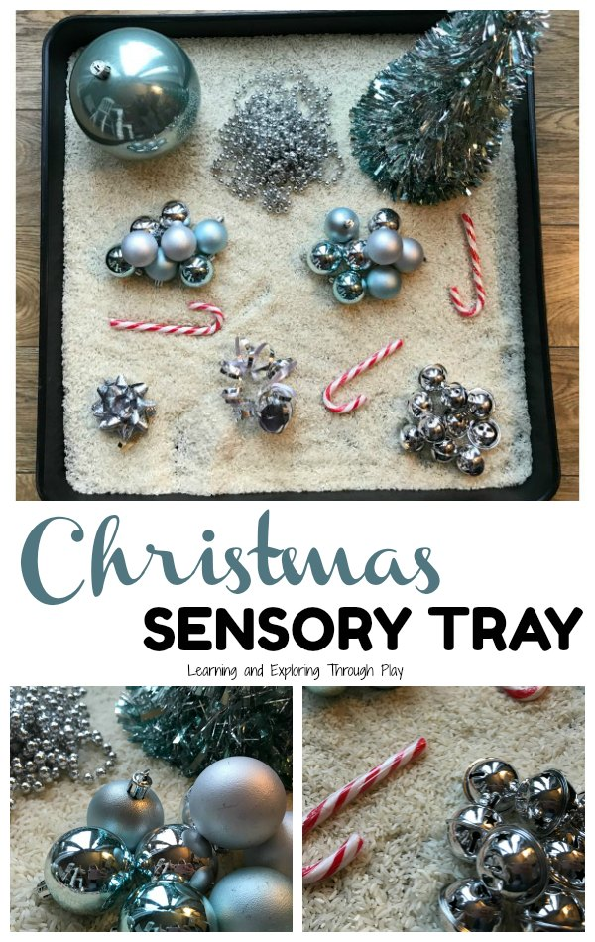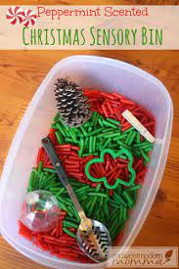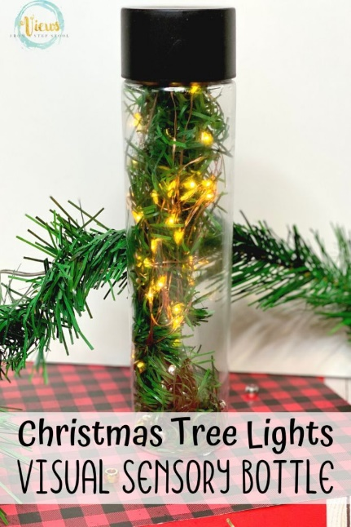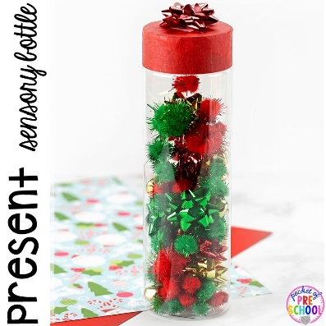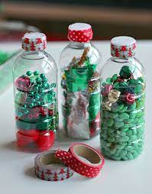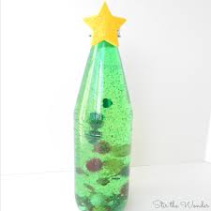

Lots of materials from around the home can be used to create a sensory experience such as flour, rice, pasta, spaghetti, water and shaving foam. You could put some of these in a baking tray and add other items such as spoons and different sized pots for filling and emptying.

Sensory bottles can be made out of many different materials. Try using items you have at home or find on a walk to create your own sensory bottle.

To make this present sensory bottle add pom poms combined with small present bows.

Collect some small branches when out on a winter walk and place them in a bottle. Lights can be added for increased visual effect.

**Christmas Sensory Bottles**

To create this Christmas tree sensory bottle use a green bottle then add pom poms, glitter and water. Cut out a star and stick it on top of the bottle to finish.