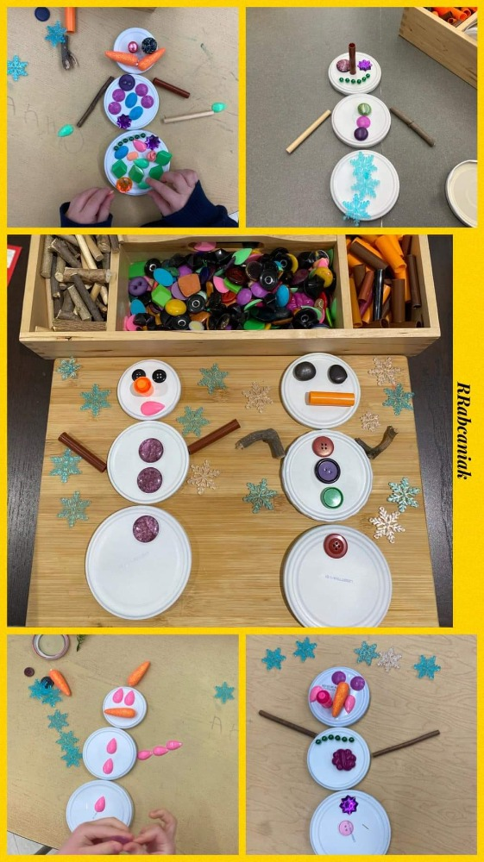
Make a snowman
You will need:
- Bottle tops/buttons
- Various decorative materials e.g tissue, pom poms, sticks etc

Activity:
Build a snowman using loose parts and materials. Use bottle tops, buttons or any other circle shapes for the body. Use other items to decorate the snowman, Encourage child to make their own decorations e.g cut out a triangle piece of paper for the nose. See if your child can count how many arms, eyes, buttons etc.

