**Christmas Paper Chains**



Cut some coloured paper into strips and fix them together to make a paper chain. Make a repeated pattern with them like red, green, red, green

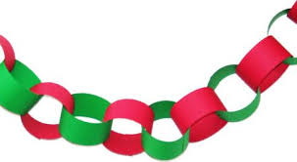

If your child can do this easily make it harder using three colours or do two reds, one green, two reds, one green. Recognising patterns is an important skill in maths and starts like this.

**Christmas countdown**

You could turn this into an advent calendar to count down to Christmas. Help your child to make a paper chain using the same amount of links as there are days left until Christmas Day. Count how many links there are each day and each day remove one link and ask your child to recount the remaining links. Carry on like this until it is Christmas Day. Merry Christmas