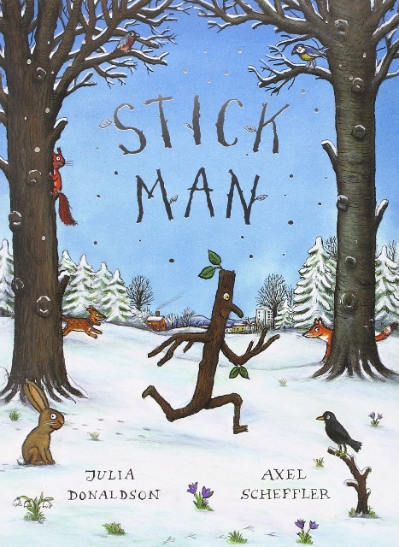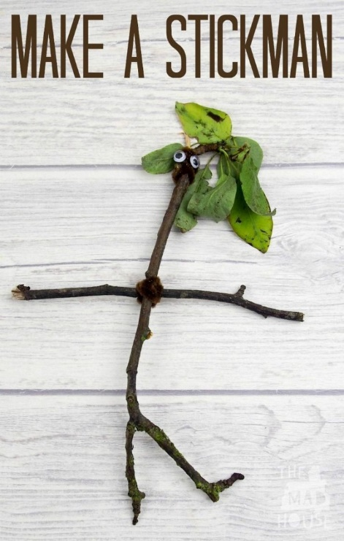

Build a stickman

This week at nursery we are reading the stickman book, where stickman gets lost and must make his way back to his family in time for Christmas.

Activity:

Go on a stick hunt in the garden or the park. Encourage your child to gather a variety of sticks, and talk about if they are long, short, big, or small. Once you have some sticks, take them back home and put the sticks together to form a body, you can use string or tape to do this. Once the stickman’s body is made, encourage your child to use loose parts and household items to decorate. You could use leaves, pom poms, and even materials for clothes.

You will need:

* Sticks/twigs
* String, wool, or tape
* Leaves
* Loose parts