**Christmas finger print painting**

**Things you will need:**

* 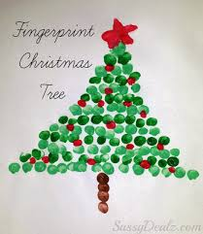Paints
* Paper
* Pen
* Paint trays

**Method**

Firstly, you will need a piece of paper and the paints on a paint tray. Using your finger start making up your tree using different colours for baubles and the base of the tree for the trunk. You will also need to make a star for the top. Make it as creative as you like, there is no wrong way of doing it.