Playdough Christmas tree

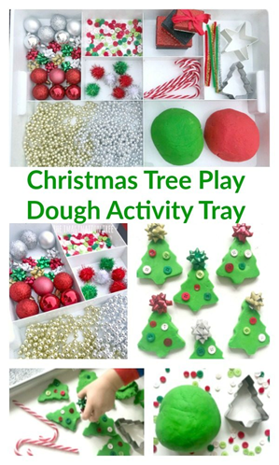

Resources

* Playdough
* Safety scissors
* Rolling pin
* Cutters
* Sequins
* Tinsel
* Wrapping ribbon
* baubles

Using the green playdough (make usual playdough with 2 cups of flour, 1 cup of salt and 1 cup of water added gradually so it doesn’t get too sticky. Add green food colouring to the water.) Make a tree. Remember it’s all about the process not the end product as it’s in the process where the children explore and use their own ideas. It doesn’t matter if it doesn’t look like a tree at the end.

Whilst doing this activity, talk about what you are doing. It may feel strange but it helps children learn as they learn your language. For example

“I’m making a tree. How may pompoms do you think I should put on? Can you help me I keep getting the wrong number?”

Ask they what they are doing. Copy their ideas if they are good ones.

To draw their attention to size you might say “My trees smaller than yours. I’m going to make a bigger one” or “my tree is taller than yours can you make a tall one?”

Have fun