Paper Snowflakes
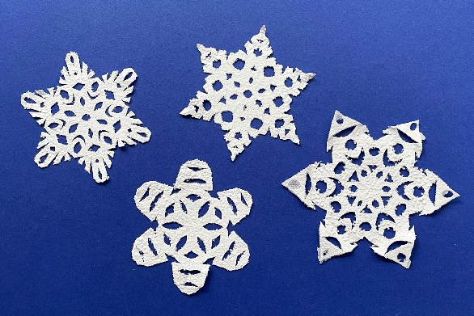
What you will need:
- Paper
- Scissors

- Get your piece of paper and fold it diagonally to make a triangle.
- Fold the paper triangle in half, so that the pointed meet each other
- Fold your paper triangle in thirds, this should overlap the left hand pointed corner over the triangle
- Overlap the right handed pointed corner over the triangle. You might need to adjust the folds a little bit to get the side to match up.
- Get the scissors and trim the pointed ends of the paper triangle.
- Then you can use the scissors again to cut your paper triangle. You can cut out different shapes with your child. Or they can cut what they would like.
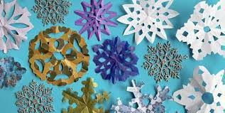

I have included visual instructions below:

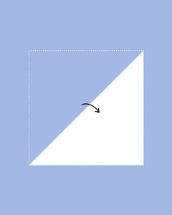


Step 1
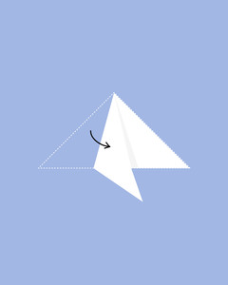
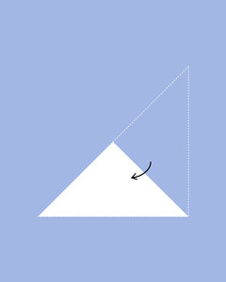

Step 2 Step 3

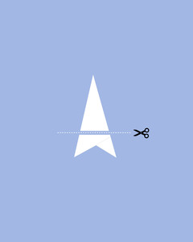
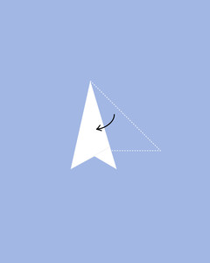

Step 4 Step 5
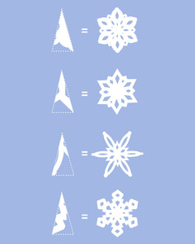

Step 6

Christmas Tree Sorting

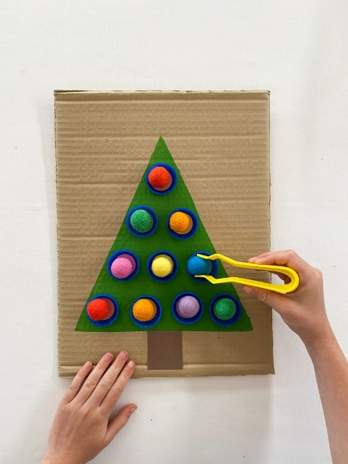
What you will need:
- A piece of cardboard
- Pencil
- Ruler
- Green paint or green crayons, marker pens or pencils
- Glue
- Recycled bottle tops
- Circle stickers or use coloured paper
- Pom poms
- Tweezer or tongs

- Cut a piece of cardboard to any size that you would like. Then use the pencil and ruler to draw out a triangle shape and paint it green. You can add a star on top of the Christmas tree, if you want too. If you don’t have green paint, then you can use crayons, marker pens or pencils.
- When your paint is dry, you can glue the bottle tops onto the tree. You want to line the bottle tops in rows but you can spread them across the tree in any pattern that you like.
- Label the bottle tops with the circle coloured stickers. If you do not have circle coloured stickers, then you can use coloured paper and then cut them into circles.
- You can now use the pom poms to match the colours in the bottle tops. You can get the child to use their hands for the activity or they can use tweezers or tongs for their fine motor skills.
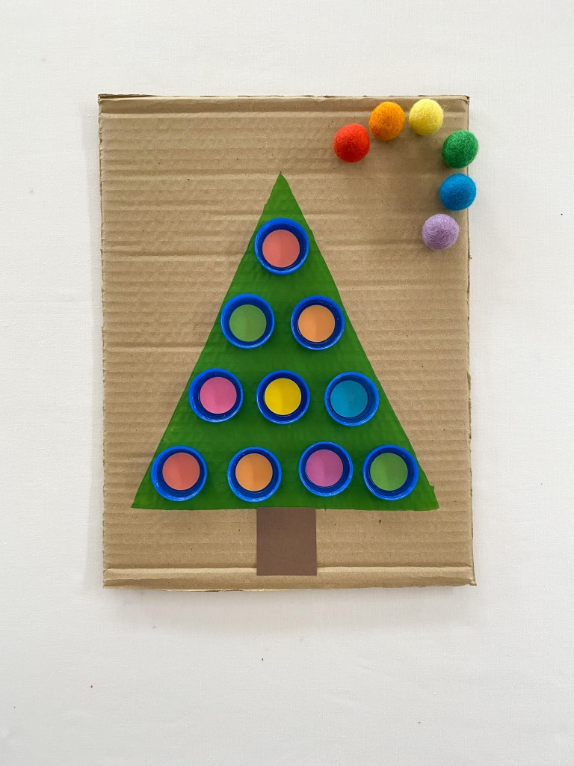

Snowman Tissue box bowling
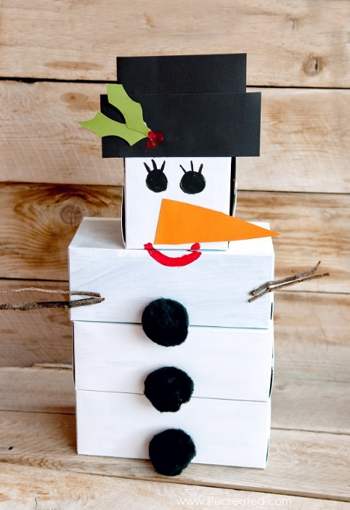
What you will need:
- Empty tissue boxes
- White paint and a brush
- Orange and black card or paper
- Black marker or paint
- Buttons or pom poms
- A ball

- Get your tissue boxes and paint them white to make your snowman. These can be any size of tissue box. After they have dried you can stack them on top of each other.
- Then get your child to decorate the snowman with you. You can use the orange card for the nose and the black card for the hat. Then use the black marker or paint for the eyes.
- You can add buttons or pom poms onto your snowman for the buttons on his body. Then use sticks for the snowman’s arm.
- Finally, you can use the ball to knock over the snowman. This can be played over and over again.

