WEEK 1  08/09,06/10,10/11  08/12,19/01,23/02 | 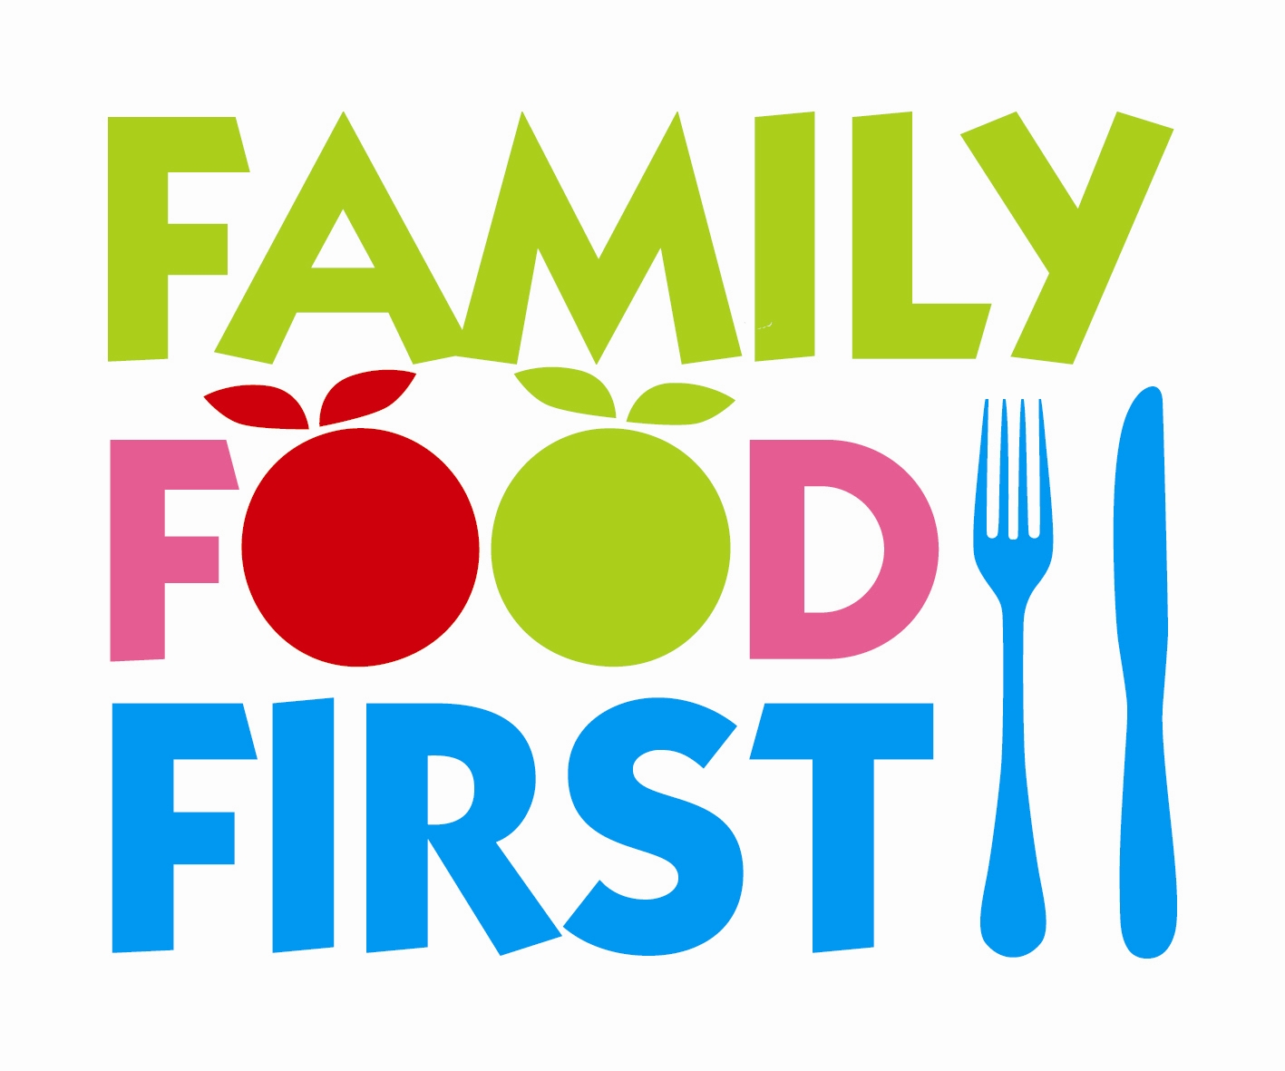 CHAPEL STREET NURSERY SCHOOL
 | MONDAY | TUESDAY | WEDNESDAY | THURSDAY | FRIDAY
LUNCH | Vegetable  Sausage & beans  Wholemeal Pasta  Salad | Lamb meatballs in  Tomato sauce  Boiled rice  Broccoli | Vegetable & bean  Casserole  Mashed potatoes | Chicken nuggets  Sweet potato wedges  Sweetcorn | Salmon fishcakes  Boiled potatoes  Peas  Carrots
VEG  OPTION |  | Vegetable meatballs |  | Vegetable nuggets
DESSERT | Lemon Sponge  Custard | Eton mess  Mixed berries | Rice Pudding  Peach Puree | Fresh fruit  Salad | Apricot & raisin  Flapjack

WEEK 2  15/09,13/10,17/11  15/12,26/01,02/03 | CHAPEL STREET NURSERY SCHOOL
 | MONDAY | TUESDAY | WEDNESDAY | THURSDAY | FRIDAY
LUNCH | Tuna pasta  [wholemeal pasta]  Tomato & cucumber  Salad | Roast Turkey  Roast potatoes  Carrots & Broccoli  Gravy | Lentil & vegetable Cottage Pie  Cabbage, Green beans | Sausage roll  Potato wedges  Baked beans | Cheese & tomato  Pizza  Salad
VEG OPTION |  | Roast Quorn fillets |  | Vegetable sausage  Rolls
DESSERT | Jam Sponge  Custard | Jelly  With Fruit | Apple & sultana  Cookie | Pear & raspberry  Crumble  Custard | Chocolate tart  Cream
WEEK 3  22/09,20/10,24/11  05/01,02/02,09/03 | CHAPEL STREET NURSERY SCHOOL
 | MONDAY | TUESDAY | WEDNESDAY | THURSDAY | FRIDAY
LUNCH | Vegetarian sausages  Mashed potatoes  Cabbage  peas | Sweet& sour Quorn  Fried rice  Carrots  Prawn crackers | Spaghetti Bolognaise Salad | Chicken & veg hotpot  Cauliflower  broccoli | Fish fingers  Oven Chips  Grilled tomato  Peas
VEG OPTION |  |  | Vegetable bolognaise | Chickpea & veg  Hotpot
DESSERT | Orange & sultana  pudding  Custard | Strawberry  Mousse | Toffee & date  Sponge  Custard | Lemon & orange  Cheesecake | Bakewell tart  Custard

WEEK 4  29/09,04/11,01/12  12/01,16/03 | CHAPEL STREET NURSERY SCHOOL
 | MONDAY | TUESDAY | WEDNESDAY | THURSDAY | FRIDAY
LUNCH | Potato & cauliflower  Korma  Boiled brown rice  Peas | Beef burgers  Potato wedges  Salad | BBQ Chicken & Peppers  Cous Cous  Broccoli | Cheese & potato  Bake  Carrots  Sweetcorn | Cod & Spinach  Fishcakes  Oven chips  Baked beans
VEG OPTION |  | Vegetable Burgers | BBQ Quorn
DESSERT | Apple crumble  Custard | Ice cream  Strawberry puree | Pineapple & melon  Fruit salad | Chocolate pudding  Chocolate sauce | Shortbread  Biscuits

