**Toilet roll characters**

**Things you will need:**

* Toilet roll
* Craft materials (anything you have at home).
* 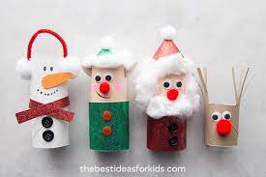glue
* googley eyes/ pen
* cotton wool
* paper

**Method**

Decide which character you would like to decorate for example you might want to do a snowman. So with your toilet roll insert you can start to decorate him how you want. You might want to add eyes using googley eyes or using a pen. You might want to add a hat or scarf and a carrot nose. You could use tissue and colour it in to stick on or buttons from an old top you no longer wear.