**End of year report**

The children have had a very good year and have been exposed to some wonderful opportunities and experiences. The nursery has had the small furry animals, the live eggs, the caterpillars, a trip to Southend, the farm visit as well as some activities organised for Fun Fridays and Thrilling Thursdays. The children have enjoyed a water day, a maths day using playdough, various culture days and visitors who have given up their time to talk to the children. After school activities have included the Christmas bazaar, Easter fete and the up-coming Summer Fayre. These times have not only been about raising some extra funds for the nursery, but it gives a sense of belonging and supports community partnerships. Regular drop in sessions and stay and play have been organised some were highly supported, however there are still families who are difficult to reach. There is a weekly Head teacher newsletter and letters are printed off and given to those families without email addresses- some of these being EYPP children. Parents are encouraged to attend parent’s evenings and staff have been proactive.

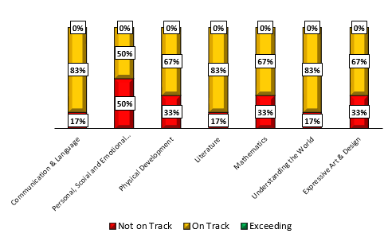EYPP boys baseline 2023 EYPP Boys June 2024

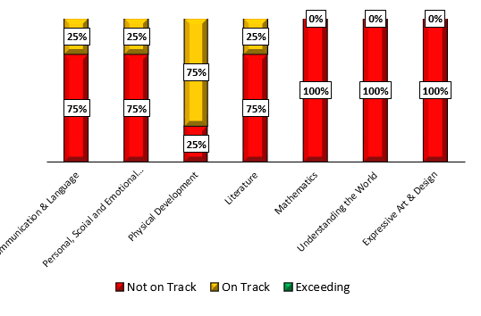

EYPP Girls baseline

NON EYPP Boys baseline 2023 NON EYPP Boys June 2024

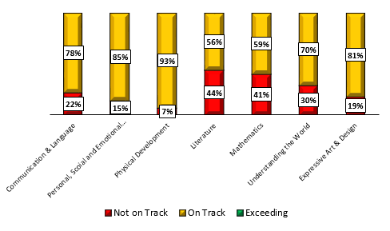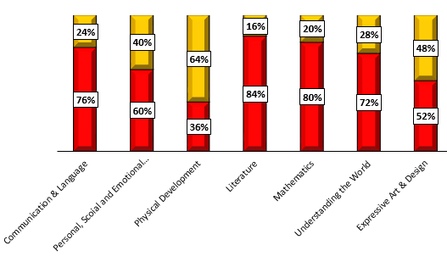

EYPP girls baseline 2023 EYPP Girls June 2024

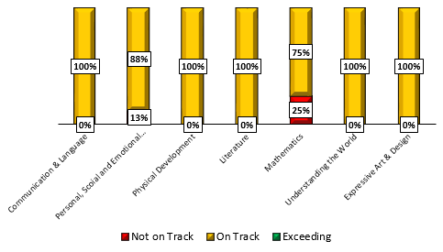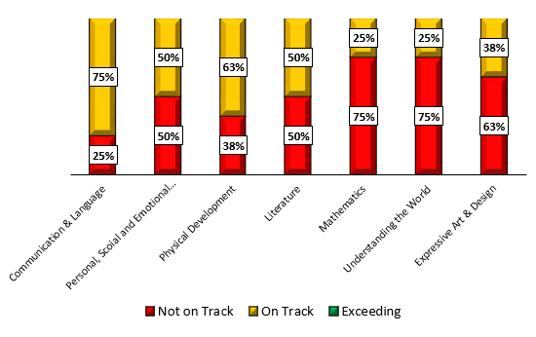

NON EYPP Girls baseline 2023 NON EYPP Girls June 2024

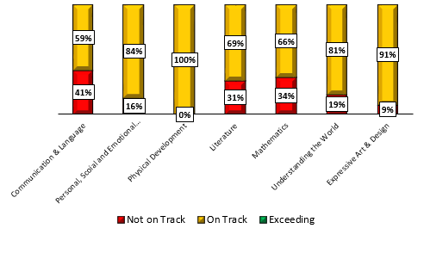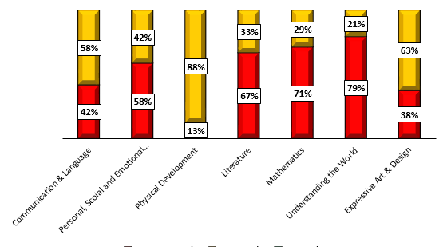

Data shows that there has been progress made for the EYPP children. Overall, EYPP girls have achieved better results than EYPP boys and girls have improved most in Understanding of the World, EAD and Mathematics. 100% EYPP girls are on track in all areas apart from Mathematics, which has switched the baseline results to 75% of the girls being on track.

Looking at the EYPP boys’ data, they have also made an improvement and Understanding of the world has seen the most improvement, closely followed by Maths and EAD. The data shows EYPP boys are still needing support in PSED.

Comparing the data with NON EYPP children, Physical development in the girls remains high and Girls Mathematics is falling behind. There are a large number of girls with EAL and this has affected the stats for NON EYPP Girls communication & language.

For the NON EYPP Boys, data shows there are still a high percentage of children off track in literature, maths and understanding of the world, however comparing these figures to the baseline shows a definite improvement in the three areas.

Following on from the action plan in May, Unfortunately, making number activities was not achieved for the children who are off track and Karen didn’t get to meet with the Family workers to put any beneficial support in place in time for PSED. Karen will speak to the family workers to try to squeeze in a nurture session for those leavers who are finding this time of year difficult, otherwise this will be done as a separate PSED session in class.

Karen spoke with Sarah G about the data as there appeared to be a few discrepancies and a deep dive will be completed as to why this is. Some examples of this is, it could be that staff have not used a best fit approach to recording on/off track, the benchmarks for the remaining children have not been taken into account, expectations are different and new starters may need their own baseline.