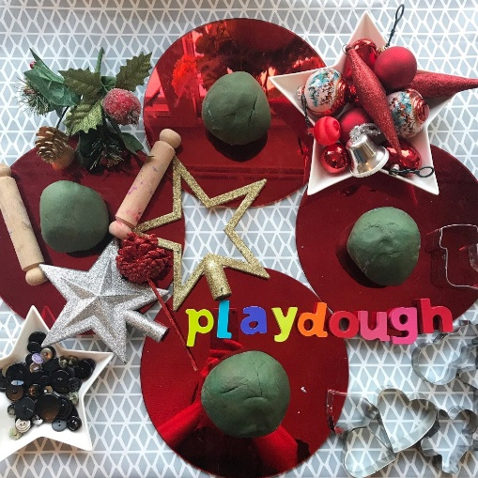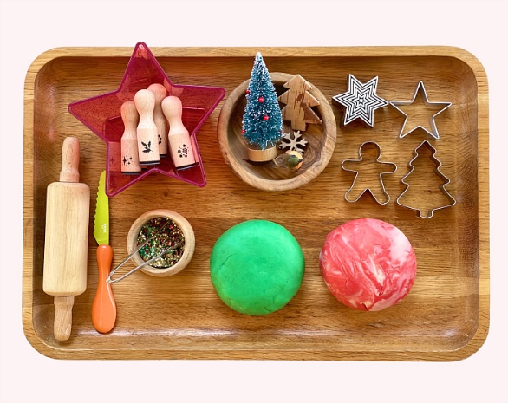Christmas playdough

Activity:

Encourage your child to make their own playdough

Recipe:

In a bowl, add 2 cups water, 2 cups flour, 1 cup salt, and 2 tbs cooking oil. Combine ingredients together using your hands until the dough meets your desired consistency. Add more flour or water if needed.

Once the dough is formed, add paint or food colouring of your choice.

You could also add extras, such as scented oil for gingerbread or peppermint dough, or glitter if you wish.

If you have any cookie cutters at home you can use these to cut out shapes from the play dough.

